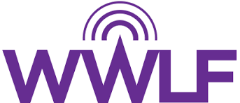

The Women’s Wireless Leadership Forum
2022 Mentor Questionnaire

MEMBER INFORMATION:

Name (First, Last):

Email Address: Phone Number:

Company: Title:

MENTOR QUESTIONAIRE:

- How long have you worked in the wireless industry?

- What are your primary goals for this mentoring relationship?

- Why do you want to be a mentor?

- What areas do you have prior and current experience in?

- What is one thing you like to do in your personal life?

- What days/times work best for your mentoring sessions? (To Be Held Every Month)

- Is there a specific woman that you would like to mentor?

- If you would like, please share any additional information, which may be beneficial in the pairing process.

Please return this form along with your resume to Kelsey Trundle at Programs@wwlf.org.

